
WELL INFORMED

Microsoft Dynamics Snap
Custom Report Generator Snap-in
For Microsoft Dynamics™ CRM 3.0 / 2007 Microsoft® Office system
Technical White Paper

February 10, 2007

Microsoft Dynamics Snap Sandbox

Table of Contents
EXECUTIVE SUMMARY 3
INTRODUCING MICROSOFT DYNAMICS SNAP 3
MICROSOFT DYNAMICS SNAP FOR CUSTOM REPORT GENERATOR 3
FUNCTIONAL OVERVIEW 4
cREATE KPI OR REPORTING DASHBOARDS IN EXCEL 6
USE parameters to filter what data to fetch 7
multi worksheet workbooks with LINKages TO PROVIDE DRILL-DOWN 7
2 way data – update data back to Microsoft Dynamics CRM 8
HIGH LEVEL ARCHITECTURE 9
PRE-Requisites for using this Snap-in 10
customizations 11
XML Grammar specification 11
I. A simple query to fetch data and render in an excel sheet. 11
II. A query to fetch data based on a condition 14
III. A query with a join 15
IV. A query with operations performed on fields (count, sum etc.) 16
V. Control Structures supported in xml (If, Loop, etc.) 17
VI. take input parameter from excel sheet to fetch data 18

EXECUTIVE SUMMARY
Many corporations implement business application systems like Microsoft Dynamics™ to automate their business processes. However, in order to accomplish what is required of their jobs, many employees tend to spend most of their time using the Microsoft Office® suite of applications. Although those workers can and do benefit from direct access to relevant business data, there are times when it would be much more productive for them to be able to obtain that information from within the Microsoft Office application in which they are working. What if there were ways to enable those information workers to access the data in Microsoft Dynamics applications from within Microsoft Office?

INTRODUCING MICROSOFT DYNAMICS SNAP
Microsoft Dynamics Snap applications do just that—they allow information workers to interact with Microsoft Dynamics business information, thereby increasing their productivity and enabling them to make decisions with confidence, all from within the Microsoft Office applications they are most comfortable with and with which they are most familiar. Now all employees can get timely and accurate data out of or into the Microsoft Dynamics applications without ever having to leave Microsoft Office. Microsoft Dynamics Snap applications help companies maximize their investment in Microsoft technology by delivering the power of the Microsoft Dynamics business applications to every single employee.

MICROSOFT DYNAMICS SNAP FOR CUSTOM REPORT GENERATOR
The Custom Report Generator Snap-in enables an Information Worker to extract, view and analyze data residing in Microsoft Dynamics CRM 3.0 as neatly formatted reports within Microsoft Excel®. Creating a new report or editing an existing one is easy since the reports are generated from meta-data that defines what data to show, where to surface it in Excel and what formatting to apply.

The Custom Report Generator Snap-in allows an Information Worker to:
- Use Excel to view and analyze data from Microsoft Dynamics CRM
- Save these reports and share as Excel workbooks
- Refresh the reports with latest data from Microsoft Dynamics CRM
- Make changes to the data and save those changes in Microsoft Dynamics CRM

The snap-in also allows a Microsoft Dynamics CRM partner or IT workers to:
- Easily create new reports to fill the needs of individual Information Workers
- Edit existing reports

Surfacing Business data from Microsoft Dynamics CRM into Microsoft Office Excel as neatly formatted reports in a generic and easily customizable manner has many benefits. It helps:
- Improve decision making ability of Information Workers as they can use the analysis, visualization and data modeling features of their favorite tool Excel, with Microsoft Dynamics CRM data
- IT Departments serve the Information Workers better by easily configuring the reports to surface more or different data by configuring the XML metadata for the excel worksheet.

Custom Report Generator Snap-in works with Microsoft Dynamics CRM 3.0 and Microsoft Office 2007 and is distributed at the Microsoft Dynamics Snap site on GotDotNet.com.

This white paper is divided into two sections, the first to help you understand the features of the Custom Report Generator Snap-in and the second to provide an overview of the technology used and how to configure the snap-in to create your own reports:
- Functional overview: This section explains the Custom Report Generator Snap-in functionality.
- High level architecture and customization: This section explains the various technologies used, how they work together to provide the functionality, and how the metadata can be edited to change or create reports. Partners may use a similar framework to build additional scenarios.

To show case the utility of this snap-in, the Sales Dashboard and Forecasting report is installed in the Example Reports folder inside the Example folder section.

FUNCTIONAL OVERVIEW

Most Information Workers love the flexibility and richness of Microsoft Office Excel in allowing them analyze and model business data. Yet, the first step in achieving this objective, which is to get the business data into Excel in a convenient format requires Information Workers to toggle back and forth between applications which can be time consuming and lead to errors. Automating this process will typically require custom coding which is outside the capabilities of all but the most advanced of power users. In most cases, the Information Workers depend on the IT departments to get them this data who will write custom solution for each such scenario.

The Custom Report Generator Snap-in allows Information Workers to get the Microsoft Dynamics CRM data that they need into Microsoft Office Excel, where they want and in the format they want. By maintaining the cell bindings between Microsoft Excel worksheet cells and fields in Microsoft Dynamics CRM, the Custom Report Generator Snap-in allows an Information Worker to create rich reports and visualizations that can updated by click of a button.

IT Departments can use the customization features of Custom Report Generator Snap-in to easily create new reports or edit existing reports as per requests of the Business Users. This can be easily done by making changes to the metadata associated with a report.
The next few screenshots taken from the sample workbook that ships with the solution demonstrate how easy it can be for users to work with Microsoft Dynamics CRM data while working in their familiar Microsoft Office environment. The Workbook is created to help a Sales Manager get a quick status check of the performance of his team.

cREATE KPI OR REPORTING DASHBOARDS IN EXCEL
You can use the Custom Report Generator Snap-in to create KPI Dashboards in Microsoft Office Excel. Once a worksheet’s cells are bound to fields in Microsoft Dynamics CRM as specified in metadata, all you need to do to get the latest data is to click the Refresh button in the CRG tab of the Snap ribbon in Microsoft Office Excel. You can use any of the rich visualization and analysis features of Microsoft Office Excel with the cells bound to Microsoft Dynamics CRM data, and they will always be updated with the latest data on click of a button.

In the Sales Manager workbook sample that ships with the snap-in, the Sales Manager can open the workbook and click Refresh button with the Sales Dashboard worksheet active. The latest data related to opportunities, performance against quota and pipeline information for the chosen team or team member under him is fetched from Microsoft Dynamics CRM and the charts and cells in worksheet are updated.
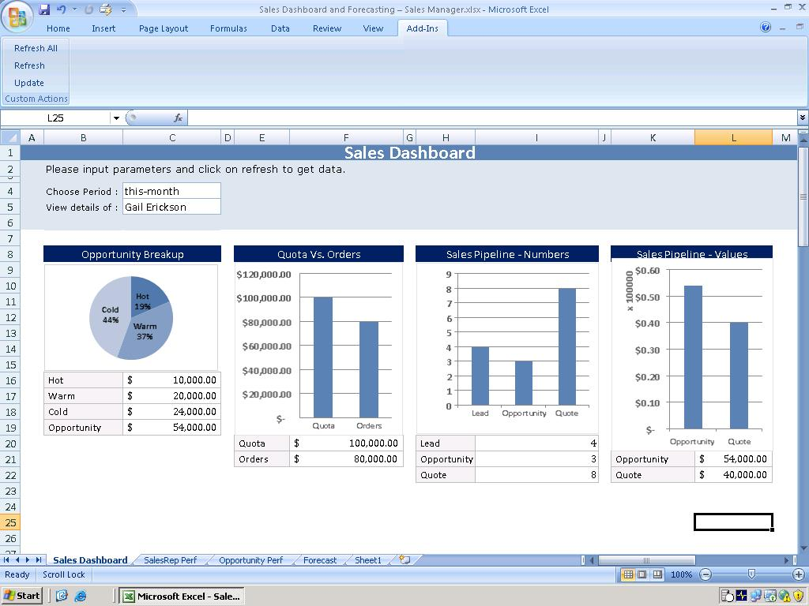

Refresh All Worksheets

To refresh all the worksheets in a workbook, click Refresh All. All worksheets in the workbook that are associated with data from Microsoft Dynamics CRM are refreshed with the latest data

Persist data

You can persist the reports as normal excel workbooks by saving the workbook. The workbook can be shared with any other user. But only users with access to Microsoft Dynamics CRM system can refresh and update the cells based on the security restrictions that apply in Microsoft Dynamics CRM.

USE parameters to filter what data to fetch
While defining the report, you can associate certain cells as input parameters in the metadata. The input parameter cells can take free text input or they can be defined to pick the possible options that exist in Microsoft Dynamics CRM. The Custom Report Generator Snap-in will use the data filled in or selected from these cells to filter or select the data that it fetches from Microsoft Dynamics CRM.

In the Sales Manager dashboard shown above, to see the details of a different period, the Sales Manager will select the period in Choose Period field and select the representative under him whose details he wishes to view in the View Details Of cell. On clicking Refresh, the sheet will refresh with the latest data from Microsoft Dynamics CRM for the selected period and team member.

multi worksheet workbooks with LINKages TO PROVIDE DRILL-DOWN
You can create a multi-worksheet report in a workbook and link a cell or a group of cells in one worksheet to open another worksheet when clicked. The new worksheet can contain more details about the metric reported in the clicked cell.

In the Sales Manager dashboard, the Sales Manager can click the Quota cell to open the Sales Rep Perf worksheet with comparison of performance of various team members in meeting the targets for the selected period, year till date and for the full year.

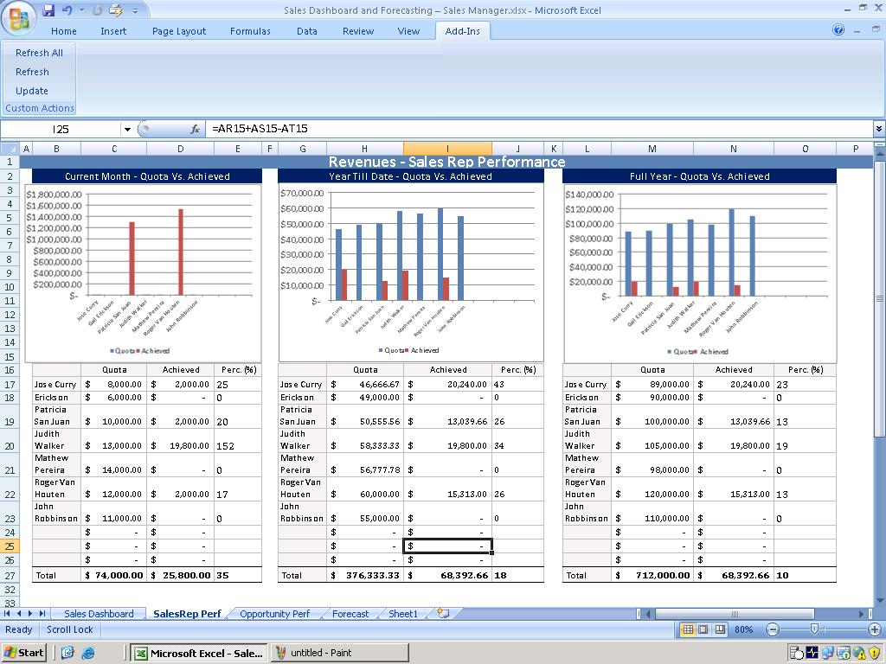
The Sales Manager can similarly see performance comparison of his team members on opportunity conversion.

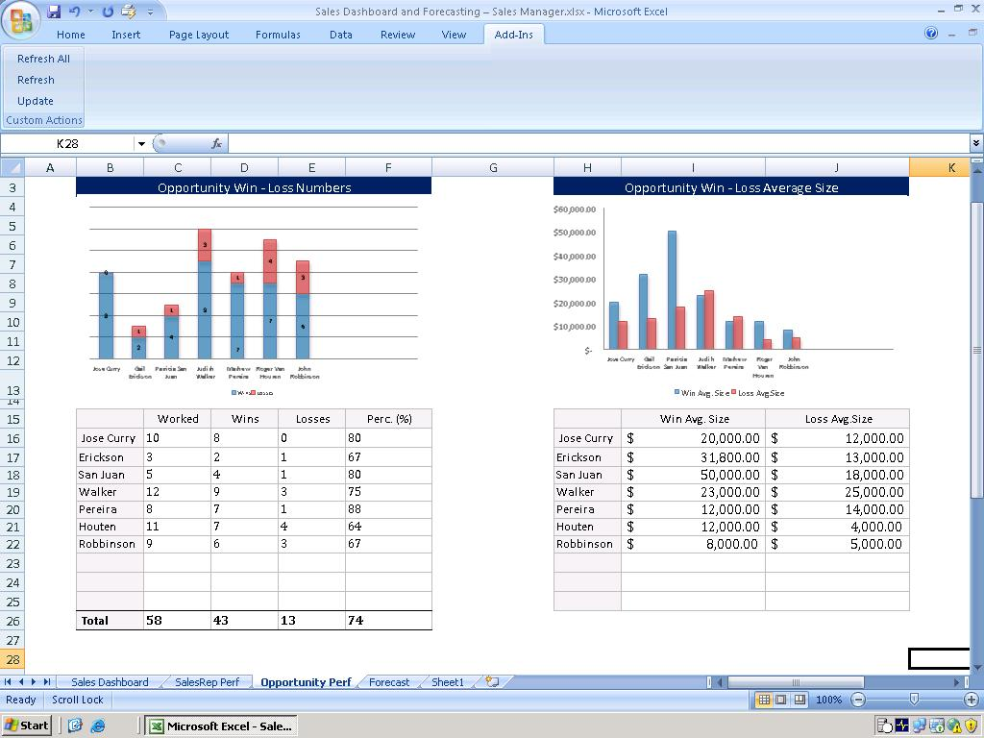

2 way data – update data back to Microsoft Dynamics CRM
Custom Report Generator Snap-in also allows users to update select data back to Microsoft Dynamics CRM system. The data that can be updated back to the Microsoft Dynamics CRM system and the fields that need to be updated have to be defined in the report definition metadata. The Information Worker can then make changes to the cell associated with the field and click Update. This will update the associated field in Microsoft Dynamics CRM.

The Forecast worksheet in the sample workbook allows a Sales Manager to look at the details of each opportunity owned by individual team members. He can then change the estimated revenue column or the win probability column to do a scenario modeling on how his team will fare under different circumstances. Once he is satisfied with the results, he can update the details back into Microsoft Dynamics CRM and instruct his team members to focus on opportunities he has selected.
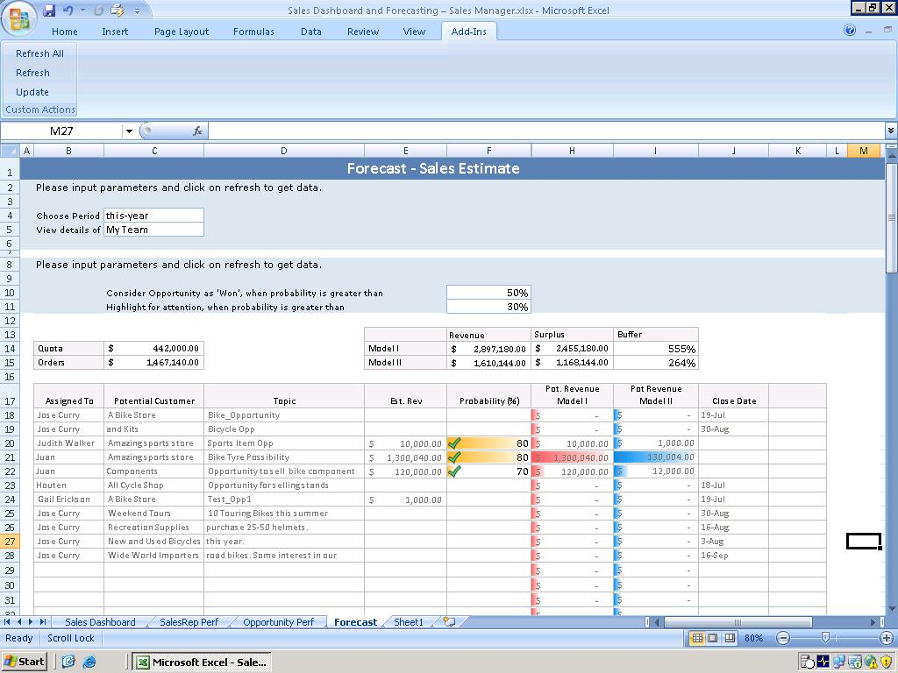

HIGH LEVEL ARCHITECTURE
Custom Report Generator Snap-in architecture can be categorized into three major components:

• Excel Add-in
• Meta-data
• Excel Worksheet

The Excel Add-in does three activities – handle events, parses meta-data, and talks to the backend using an adapter layer. The meta-data contains information about the back-end data to be retrieved in a particular schematized format. The information to be retrieved is bound to excel sheet regions using namespaces in the meta-data. The excel sheet has regions demarcated using namespaces. The excel add-in has some buttons associated with it which are bound to some events and the event handler parses information related to the event and uses the associated namespaces and the meta-data to retrieve information from Microsoft Dynamics CRM.

The Custom Report Generator Snap-in talks to the Microsoft Dynamics CRM server through web service calls. The same logic is used for updating back to the backend. It is recommended that the Microsoft Dynamics CRM web service should be setup to run in the secure https mode for enhanced security.
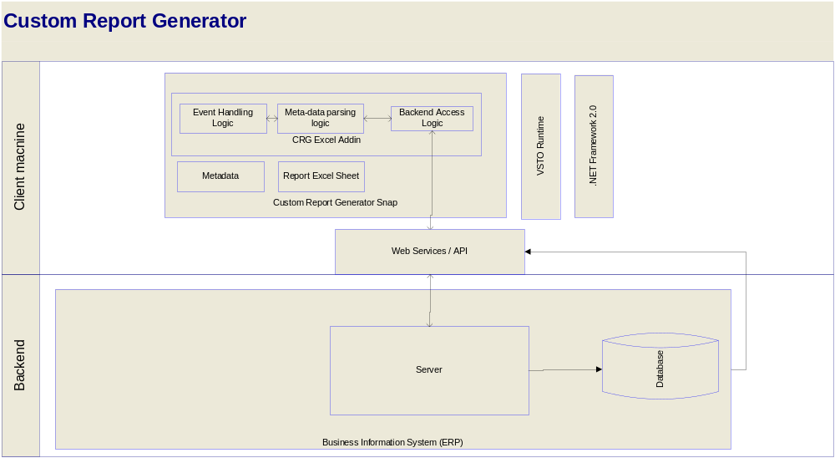

PRE-Requisites for using this Snap-in
- Microsoft Office 2007 should be installed, along with all the latest updates, and Microsoft Outlook should have been run at least once on the local machine
- Microsoft Dynamics CRM 3.0 server should be accessible through the browser client by the user
- The user should have administrative rights on the machine and have permissions and access to the Microsoft Dynamics CRM 3.0 server
- Microsoft .NET Framework 2.0 should be installed on the system
- Microsoft VSTO 2005 SE Runtime should be installed on the system
For more details on the pre-requisites and configuration requirements, please refer the installation guide in the setup package.

customizations

This section will explain how to create new reports by creating XML meta-data and associating it with an Microsoft Office Excel worksheet. The same methodology can be used to edit existing reports including the sample reports that ship with Custom Report Generator Snap-in.

To do so, we will start by defining a simple query using the XML grammar understood by the Custom Report Generator Snap-in and then move on to more complex queries. With each query, an explanation of tags used is provided to help you understand how the query is built up from the XML. Using this in conjunction with the XML metadata file that ships with the Sales Manager Dashboard sample Custom Report Generator Snap-in report will help you understand how the solution can be modified to create reports that you want. It is assumed that the reader is familiar with the model and internals of Microsoft Office Excel documents and XML specifications.

XML Grammar specification

I. A simple query to fetch data and render in an excel sheet.
<?xml version="1.0" encoding="utf-8"?>
<query>
<fetchxml>
<namespace>NAMESPACE</namespace>
<entity name="BACKEND_ENTITY_NAME">
<attribute name="BACKEND_FIELD_NAME_1" />
<attribute name="BACKEND_FIELD_NAME_2" />
---
---
---
<attribute name="BACKEND_FIELD_NAME_N" />
</entity>
</fetchxml>
</query>

- Header Tag

<?xml version="1.0" encoding="utf-8"?>
- Start tag of the xml coding
- There is one and only one header tag in the first line of any XML grammar.

2. Query Tag
<query>
</query>

- Start and Closing tags that enclose the entire grammar of a particular workbook.
- There is one and only a pair of query tags (one opening and one closing) per workbook.

3. Fetchxml Tag
<fetchxml>
</fetchxml>

- Start and closing tags that enclose a particular data query and namespace.
- There can be one or multiple pairs of fetchxml tags enclosed in a pair of query tags.

4. Namespace Tag
<namespace>EXCEL_NAMESPACE_NAME</namespace>

- Start and closing tags that enclose the name of a excel namespace.
- A namespace is a range of regular contiguous cells defined as a namespace in excel, it could be a matrix of cells or a column or a row or even a single cell.
(regular contiguous cells means range of cells defined as column1row1:column2row2 – for e.g. D1:G8 – is a 4 x 8 matrix of cells)
You can find this in the formulas ribbon in the named cells section.
- EXCEL_NAMESPACE_NAME is the place holder where the name of the namespace is to be entered.
- This tag defines where the data is going to be shown in the excel sheet.
- There is one and only one pair of namespace tags enclosed in a pair of fetchxml tags.

5. Entity Tag
<entity name="BACKEND_ENTITY_NAME">
</entity>

- Start and closing tags that enclose the query that retrieves the data from the backend.
- A entity name in the backend is usually a backend table
(opportunity, lead, quote etc are examples of entities in CRM)
- BACKEND_ENTITY_NAME is the place holder where the name of the entity is to be entered.
- This is the tag that defines which data is going to be shown on the excel sheet.
- There can be one or multiple pair of entity tags enclosed in a pair of fetchxml tags.

6. Attribute Tag
<attribute name="BACKEND_FIELD_NAME" />

- Start and closing tags that enclose the name of the field in the backend that has to be retrieved.
- A entity in the backend is usually a backend field name in a table
(name, customerid, estimated value, etc are examples of attribute names in CRM entity opportunity)
- BACKEND_FIELD_NAME is the place holder where the name of the entity is to be entered.
- This is the tag that defines which fields are going to be shown on the excel sheet.
- There can be zero or multiple pair of attribute tags enclosed in a pair of entity tags.

Explanation Section I:
- The power user defines a namespace in excelsheet.
- The power user includes the Header tag, the query tag and the fetchxml tags.
- Within the fetchxml tag he includes the namespace tag(has to be only one) where he gives the name of the namespace he has defined in xml.
- Within the fetchxml tag he includes the entity tags (can be multiple) where he gives the schema table names of the backend from which he wants to display data in the excel sheet.
- Within the entity tag he include the attribute tags (can be zero or one or multiple) where he gives the schema field names of the backend, which he wants to display in the excel sheet.
- Data is fetched from the attribute fields in the entity table and displayed in the namespace.

II. A query to fetch data based on a condition

<attribute name="BACKEND_FIELD_NAME” />
<filter type="and/or">
<condition attribute ="BACKEND_CONDITION_FIELD_NAME"
operator="OPERATOR_NAME"
value="COMPARE_VALUE"/>
</filter>

7. Filter Tag:
<filter type="and/or">
</filter>

- Starting and closing tags that let a user specify the conditions in a conditional query to retrieve data.
- type specifies the way multiple conditions are applied. It could be and or or.
- There is zero or one filter tag enclosed in a entity tag.

8. Condition Tag
<condition attribute ="BACKEND_CONDITION_FIELD_NAME"
operator="OPERATOR_NAME"
value="COMPARE_VALUE"/>

- Starting and closing tags that let the user specify the conditions
- attribute specifies the backend field name in the entity
BACKEND_CONDITION_FIELD_NAME is the place holder where the name of the backend field to be compared is to be entered.
- value specifies the value that has to be compare to the attribute.
COMPARE_VALUE is the place holder where the value is to be entered.
- operator specifies the operator to use to compare the attribute and the value
OPERATOR_NAME is the place holder where the comparison operator is entered.
- There can be one or multiple pair of condition tags enclosed in a filter tag.

Explanation Section II:
- The power user follows steps 1 to 7 in Explanation Section I.
- Within the entity tags, following the attribute tags, he includes the filter (zero or one) tag where he mentions the operator between different conditions.
- Within the filter tag, he includes the condition (one or multiple) tags, where he specifies the different conditions by mentioning the backend field name, the value and the comparison operator.
- Data is fetched from the attribute fields in the entity table and displayed in the namespace, subject to the conditions in the condition tags.

III. A query with a join

<entity name="BACKEND_ENTITY_NAME">
<attribute name="firstname" />
<linked-entity name="BACKEND_JOIN_ENTITY_NAME"
from="BACKEND_JOIN_ENTITY_FIELD_NAME"
to="BACKEND_ENTITY_FIELD_NAME"
</linked-entity>
</entity>

9. Linked-Entity Tag:
<linked-entity name="BACKEND_JOIN_ENTITY_NAME"
from="BACKEND_JOIN_ENTITY_FIELD_NAME"
to="BACKEND_ENTITY_FIELD_NAME"
</linked-entity>

- Starting and closing tags that let a user specify the join conditions in a query to retrieve data.
- name specifies the backend schema table that is being joined to the table mentioned in the entity tag.
- from specifies the backend schema field name in the table mentioned in the linked-entity tag on which join has to happen.
- to specifies the backend schema field name in the table mentioned in the entity tag on which join has to happen.
- There is zero or multiple Linked-Entity tags enclosed in a entity tag.

Explanation Section III:
- The power user follows steps 1 to 7 in Explanation Section I.
- Within the entity tags, following the attribute tags, he includes the linked-entity tag (zero or multiple) where he mentions the backend schema table name in name and also the join field names in from and to
- Data is fetched from the attribute fields in the entity table and displayed in the namespace, subject to the conditions in the name, from, to tags.

IV. A query with operations performed on fields (count, sum etc.)
<namespace>EXCEL_NAMESPACE_NAME</namespace>
<action type="COLUMN_OPERATOR">
<entity name="BACKEND_ENTITY_NAME">
<attribute name="BACKEND_FIELD_NAME” />
</entity>
</action>

10. action Tag:
- starting and closing tags that let a user specify the operations in a query .
- type specifies the type of operation (could be count, sum, average, diff) that needs to be performed on the backend field mentioned in the attribute tag in backend table mentioned in the entity tag.
- There is zero or multiple action tags enclosed in a namespace tag.

Explanation Section IV:
- The power user follows steps 1 to 7 in Explanation Section I.
- Within the namespace tags, he includes the action tags (zero or multiple) where he mentions the type of operation to be performed on the backend field name mentioned in the attribute tag in backend table mentioned in the entity tag
- Data is fetched from the attribute fields in the entity table and displayed in the namespace, after the operation in type tag is performed on them.

V. Control Structures supported in xml (If, Loop, etc.)
<if type=”and/or”>
<condition> “value” ==/!= “value” </condition>
<condition> “value” ==/!= “value” </condition>
</if>
<then>
…… entity query …..
</then>
<else>
…… entity query …..
<else>

11. if Tag:
- Starting and closing tags that let a user specify a if control structure.
- type specifies the type of operation (could be and / or) that needs to be performed on the multiple conditions to evaluate the total condition
- then tag has the entity query which gets executed if the condition evaluates to true
- else tag has the entity query which gets executed if the condition evaluates to false
- There can be zero or multiple if tags enclosed in a namespace tag or a action.
- There is one and only one entity tag enclosed in a then or else tag.

<loop name="NAMESPACE_NAME>">
<action type="count"> </action>
<if></if>
<entity>
</loop>

11. loop Tag:
- Starting and closing tags that let a user specify a loop control structure.
- It loops through the namespace given in attribute name, row-wise and performs the query, action or if enclosed within, for each row.
- Only one of action, if or entity tags can be enclosed by a loop at any time.
- Multiple action tags or multiple if tags or multiple entity tags can’t exist within the loop tag.
- You can get present rows any cell value of the given namespace by specifying (-1, col_offset) with input tag.

VI. take input parameter from excel sheet to fetch data

$<namespace>(<offset_row>,<offset_column>)

12. input parameter specification:
- The $ sign allows the user to specify a input parameter which could become a part of query, part of if condition etc.
- Thus xml can pick up input parameters from cells in the excel sheet and use in the xml if structure or entity tag.
- If the user has to pick up a input parameter from a cell. He would have to define those cells in a namespace. Then he can refer to them using the offset row and column from the top-left cell of that namespace, the top-right cell being 1, 1.

Explanation Section VI:
- Follow steps in Section II
- In place of the back-end compare value, user can enter a input parameter as $<namespace>(<offset_row>,<offset_column>)
- This makes the query retrieve the data when the filter condition meets the user input.

The information contained in this document represents the current view of Microsoft Corporation on the issues discussed as of the date of publication. Because Microsoft must respond to changing market conditions, this document should not be interpreted to be a commitment on the part of Microsoft, and Microsoft cannot guarantee the accuracy of any information presented after the date of publication.
This White Paper is for informational purposes only. MICROSOFT MAKES NO WARRANTIES, EXPRESS, IMPLIED, OR STATUTORY, AS TO THE INFORMATION IN THIS DOCUMENT.
Complying with all applicable copyright laws is the responsibility of the user. Without limiting the rights under copyright, no part of this document may be reproduced, stored in or introduced into a retrieval system, or transmitted in any form or by any means (electronic, mechanical, photocopying, recording, or otherwise), or for any purpose, without the express written permission of Microsoft Corporation.
Microsoft may have patents, patent applications, trademarks, copyrights, or other intellectual property rights covering subject matter in this document. Except as expressly provided in any written license agreement from Microsoft, the furnishing of this document does not give you any license to these patents, trademarks, copyrights, or other intellectual property.

© 2006 Microsoft Corporation. All rights reserved.
Microsoft, the Microsoft Dynamics Logo, 2007 Microsoft Office System, BizTalk, Dexterity, FRx, Microsoft Dynamics, SharePoint, Visual Basic, Visual C++, Visual SourceSafe, Visual Studio, Windows, and Windows Server are either registered trademarks or trademarks of Microsoft Corporation, FRx Software Corporation, or Microsoft Business Solutions ApS in the United States and/or other countries. Microsoft Business Solutions ApS and FRx Software Corporation are subsidiaries of Microsoft Corporation.
Microsoft Dynamics is a line of integrated, adaptable business management solutions that enables you and your people to make business decisions with greater confidence. Microsoft Dynamics works like and with familiar Microsoft software, automating and streamlining financial, customer relationship and supply chain processes in a way that helps you drive business success.

www.microsoft.com/dynamics

